**Run Java Code**

**Java Installation Link:** <https://drive.zappy.ai/index.php/s/exF9socH7N2inZH>

This document will explain how to run **Run Java code**.

We have created sample .jar file for addition of two numbers.

**Step 1:** Double click on **“Run Java code. Zappy”** file.

**Step 2:** Run Zappy Task window will pop up. Click on OK.

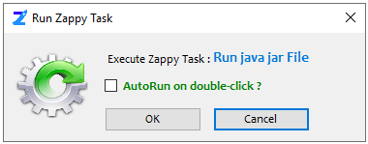

**Step 3:** Enter the Java Exe path in Input box.

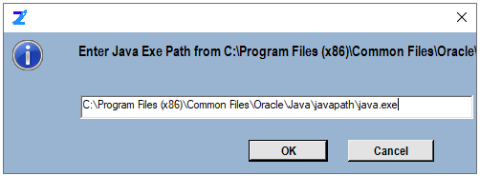

**Step 4:** Select the jar file like we have selected **Addition of Two Number.jar** file and click on Ope

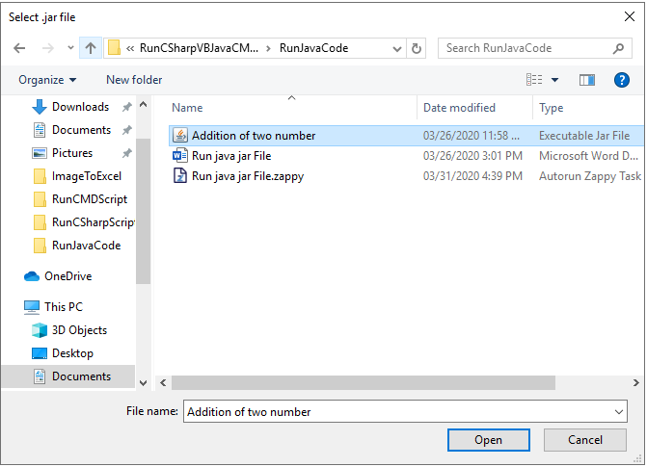

**Output:**

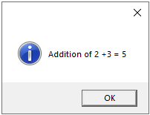

**In this way we can execute any java code using Zap.**